VENDOR/SUPPLIER SEARCH
You have a quote or invoice and you need to see if the Vendor is already in PSoft so you can process a PO or voucher.
The best way is to search by their FEI or EIN {Federal Tax ID number}. In PSoft, one FEI number matches to one PS ID number.
Now there are 2 different ways to search for a vendor in PSoft. We are going to cover both and what you need to specifically look at to confirm the vendor is not only in PSoft but also that they are an ‘Approved’ vendor. IF the vendor is not Approved or Inactive, requisitions/PO’s and vouchers cannot be processed.
IF your vendor search result is an Inactive vendor, then you will need to obtain a current W9 form and submit it to Accounting in order to update and activate the vendor’s ID number.

Let’s start with the common one we probably all use in the field and what the pitfalls are with this method.

From the Home Page, I think most of us are using the Tiles to navigate through the system, using Procurement and Purchase Orders
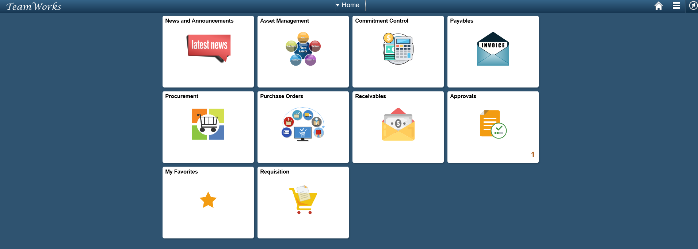

Once you click on the Tile {we’ll use Purchase Orders as the example}, you have Review Suppliers on the left hand side of your screen. This is the same link if you were to click on the Procurement Tile.

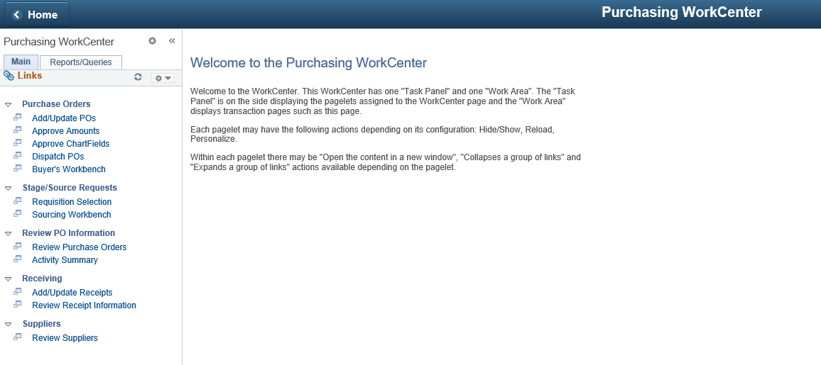

This screen gives you multiple ways to search for a vendor and you can use combinations of information at the same time to narrow down your search results.
Drop down boxes {accessed by clicking on the down arrow } provide additional criteria for search fields such as saying ‘equal to’ or ‘contains’ for the name or address searches.
As mentioned, searching by the Tax ID number is always best.

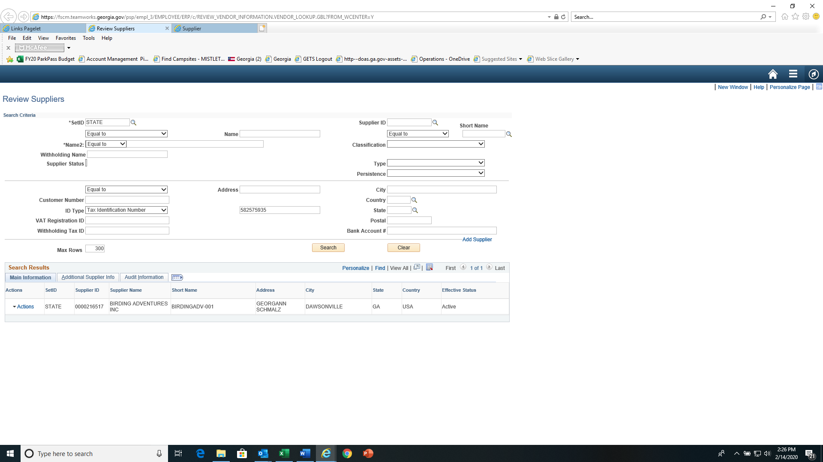

ALERT----PITFALL !!!!!!!
The Effective Status field should NOT be used to determine if a Vendor is valid/approved for you to use. This field comes from the Supplier Address Tab and indicates if an address for that vendor is valid or not. These are 2 different fields which are independent of the other---A vendor can be Inactive/Not approved and the address could be active.

At this point, all you know is that the vendor has an ID file in the system, # 0000216517.
To see the TRUE STATUS of a vendor from this screen, you would have to click on Actions, click on Maintain Supplier, and then on the next screen, Supplier Information, click the Search button.
TRUE STATUS OF A VENDOR
This is the #1 individual Supplier Information screen to review in order to determine if the vendor is “Approved” and available for you to use to create a PO or process a voucher.
As you can see, the Supplier Status is actually Inactive.
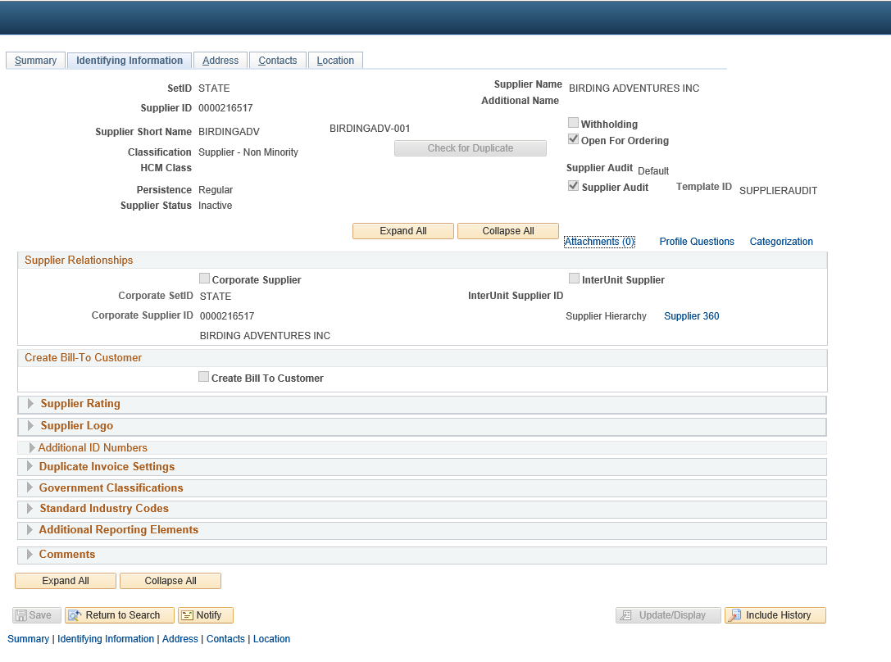
METHOD #2 – NO Pitfalls----Using the Navigation Icon

On the Home Page in the upper right-hand corner, there is a Compass Icon called the NavBar.

Click on the NavBar icon to see the right tool bar appear. Click on Navigator.

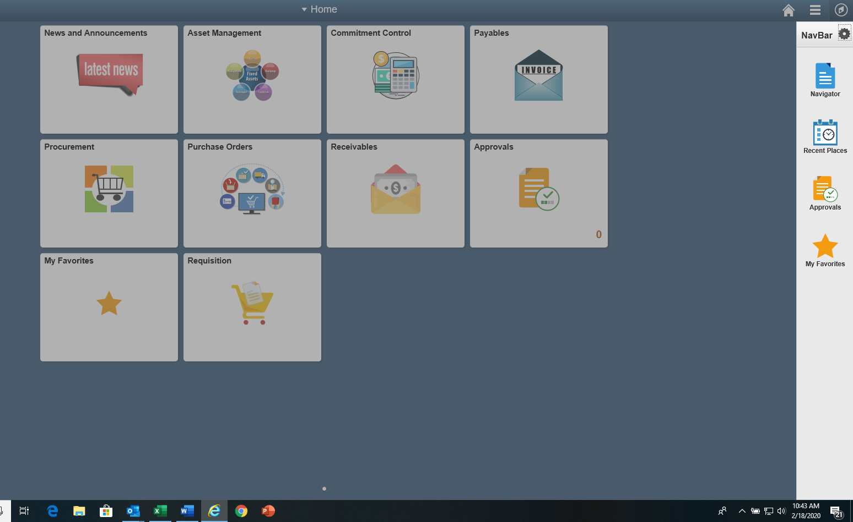

The screen widens and provides topics to select. Select Suppliers
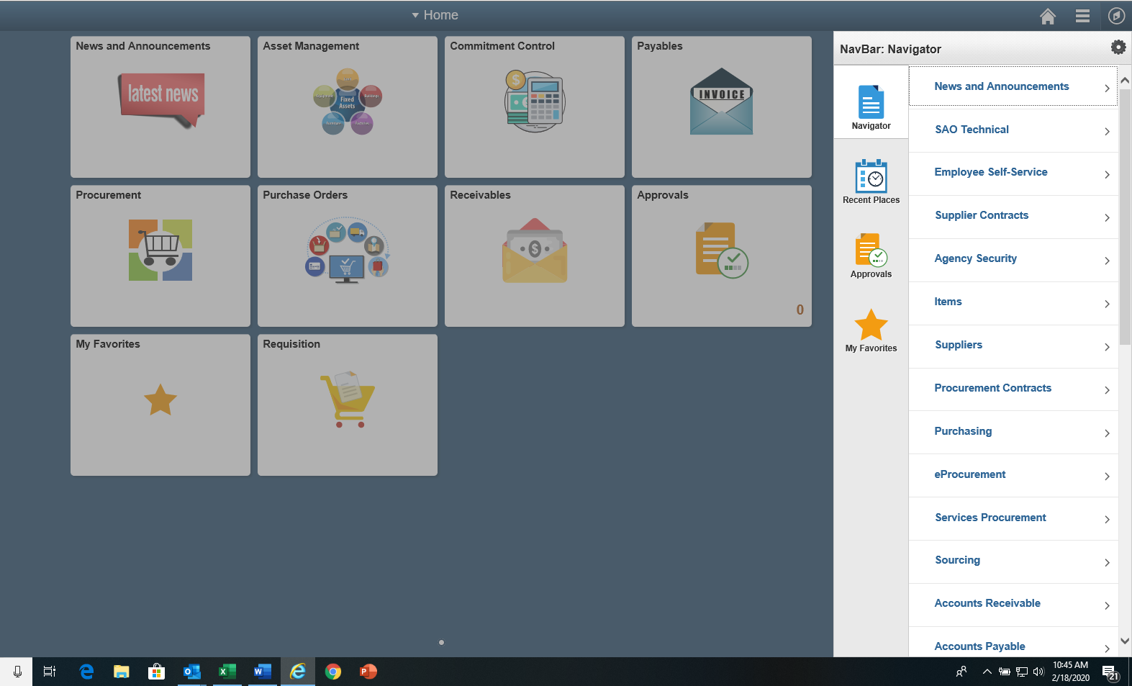

Select Supplier Information. This name should sound familiar as we used it in first illustration.
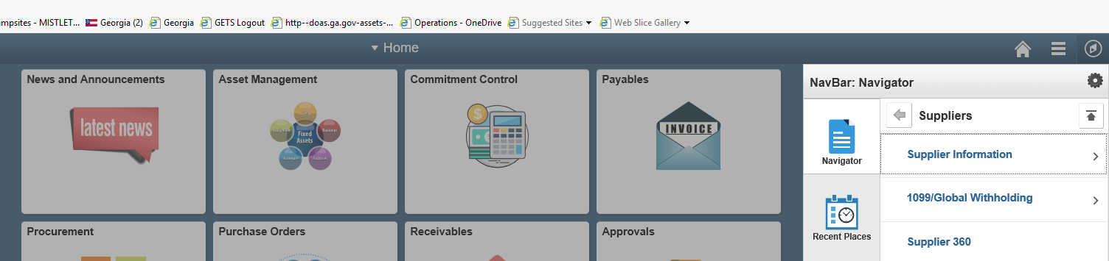
Select Add/Update
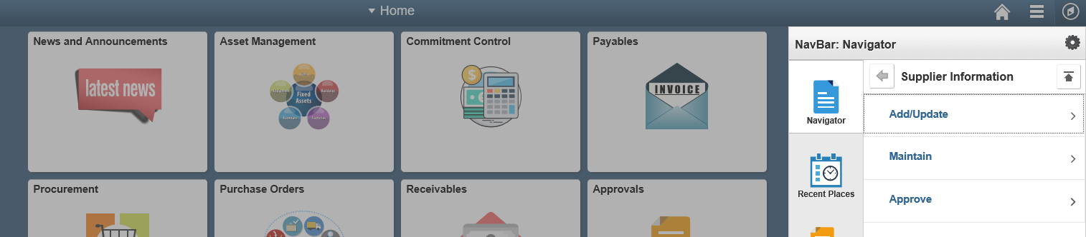
Select Supplier. You will see though that Review Suppliers appears here as well. The NavBar is just another way of navigating through PSoft.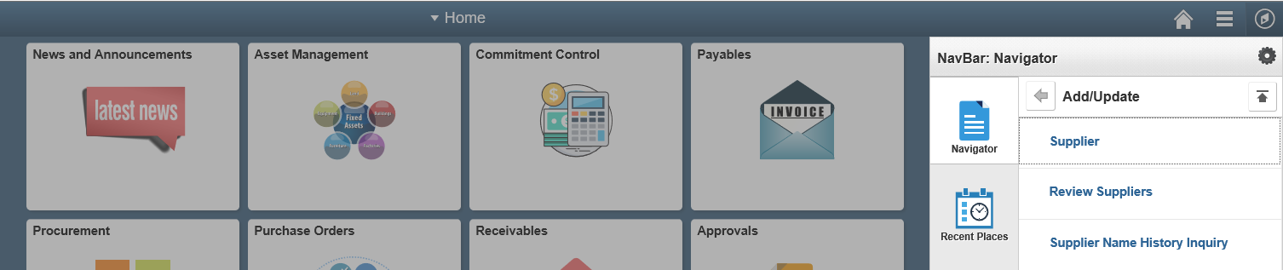
This brings up the Supplier Information page. From this screen, you can enter the first 5 letters of the person last name or first 5 of the business name and click on the Search button.

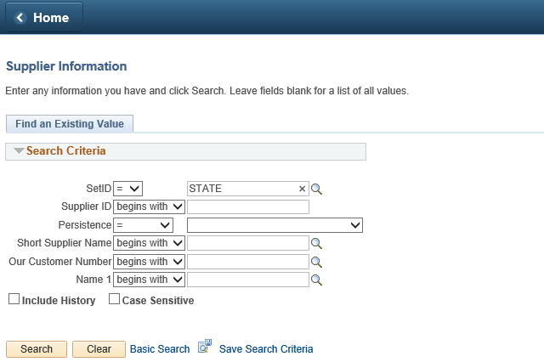
Scroll down and select one of the blue links.
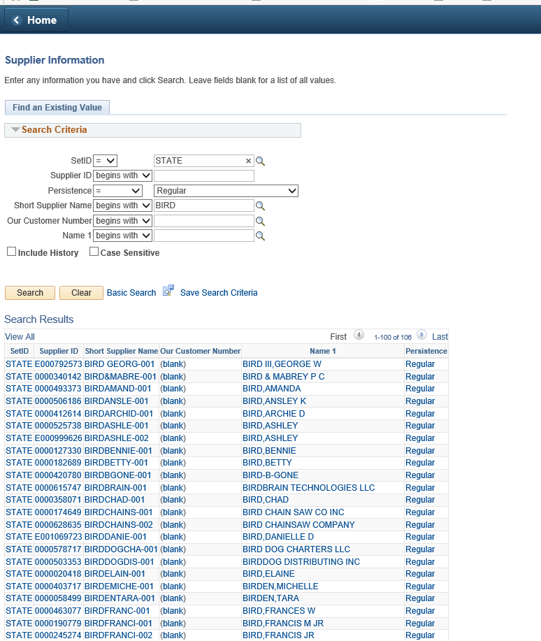

And you have arrived at the same individual Supplier Information page seen in method 1.
The TRUE Status of this vendor is Inactive. See below for other information you can review about this vendor.
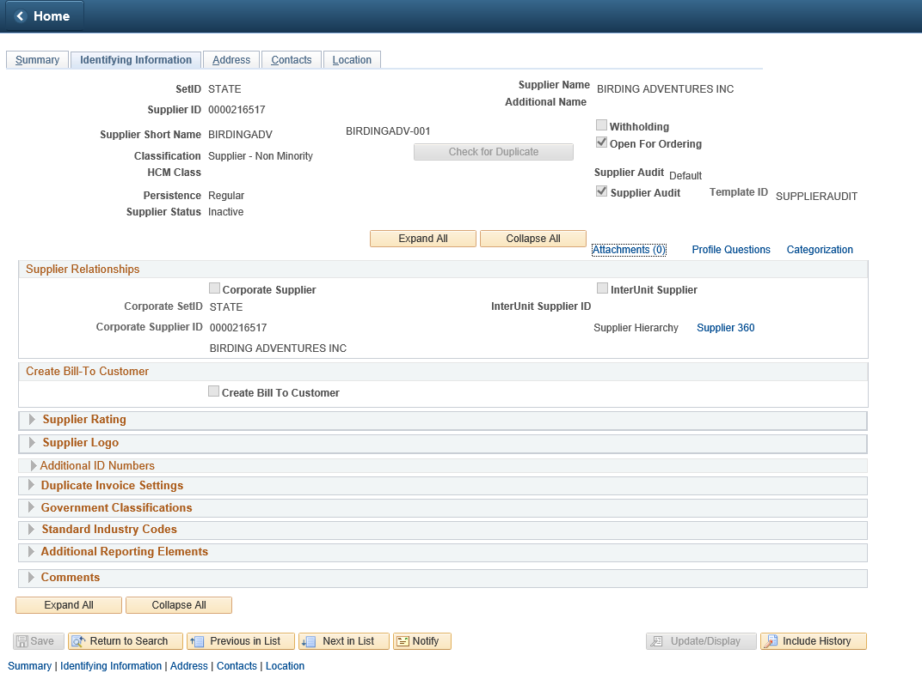

Identifying Information tab- Click on Additional ID Numbers to see the FEI/EIN/TIN number associated with this PSoft Vendor.
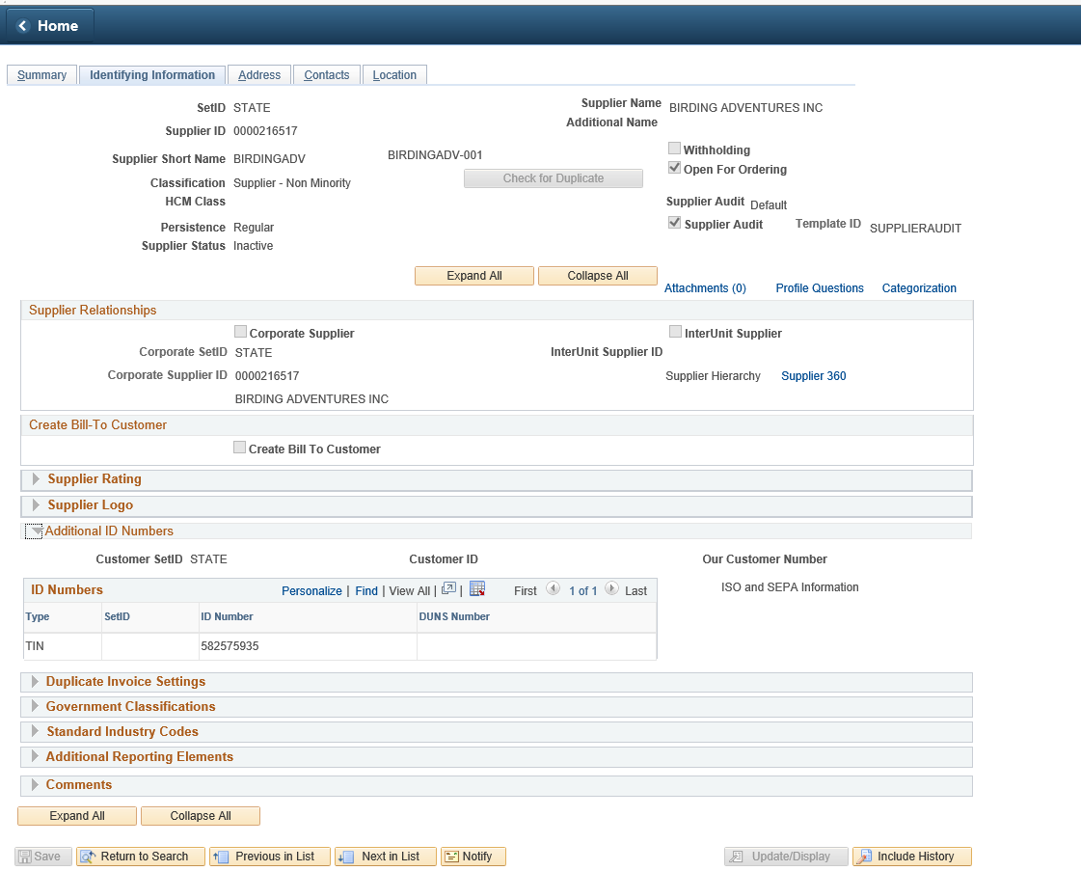
Address Tab- This tab will show you all the addresses associated for this vendor. Vendors may have several remit addresses on file so you need to review to make sure the remit address on the invoice is in the system. This vendor only has one, as seen 1 of 1 records. If more than 1, you can click on View All or use the right arrow to move to the next address ID. Each Address ID will have an effective status to let you know if you can use that address id number or not.
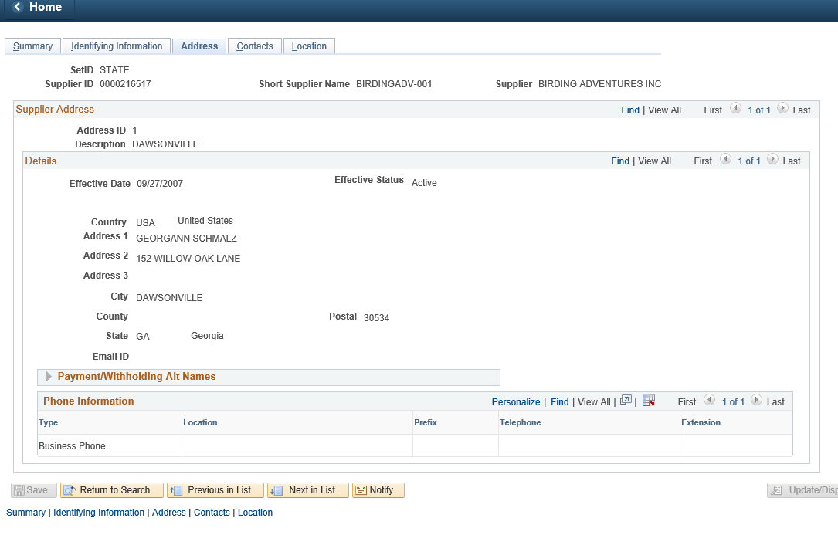

Location Tab- This tab indicates if the vendor will receive a paper check {Primary} or electronically {ACH}.
